Creating an Absence Learning Plan
An Absence Learning Plan (ALP) must be completed when a student has been absent for 3 or more days for any of the following reasons:
- Medical illness (including COVID-19)
- Family holiday (including Religious/Cultural holidays)
- Wellbeing concerns
- Extended absence
Who creates this?
Mentor teachers are responsible for creating an ALP and contacting the student’s classroom teachers to collate work to be provided to the student while the student is absent.
How to create an ALP:
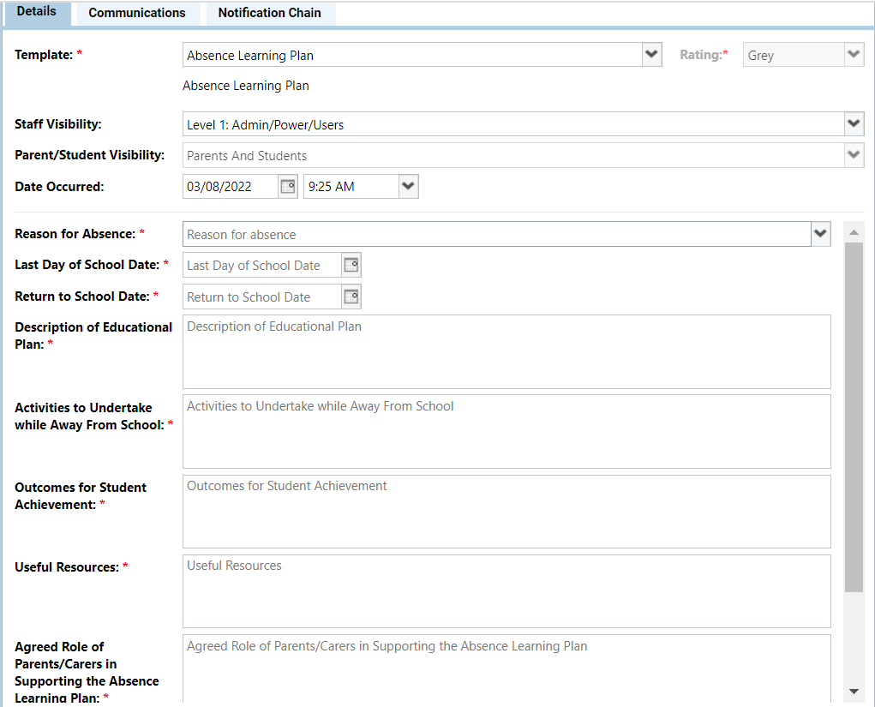
- Find your student on Compass and click ‘Add Chronicle Entry’. Scroll down until you find ‘Absence Learning Plan’ under the ‘Attendance’ heading.
- Enter in the reason for absence and absence dates in the correct fields.
- Enter in the Description of Educational Plan: “To continue with Year 8/9 coursework.”
- Enter in Activities to Undertake while Away From School: “To complete Year 8/9 Coursework provided to student via Teams pages.”
- Enter in Outcomes for Student Achievement: “To complete all set work.”
- Enter in Useful Resources: “Microsoft Teams, Pencil Case, Textbooks.”
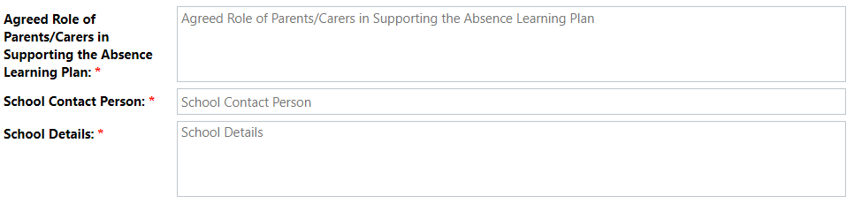
- Enter in Agreed Role of Parents/Careers in Supporting the Absence Learning Plan: “Parents are to support students in ensuring they complete their work during their time of absence.”
- Enter in School Contact Person: Mentor Teacher Name
- Enter in School Details: 8338 3600
- Click save and close.
Once the ALP has been uploaded to Compass, the Mentor teacher/Team leader will need to email the student’s classroom teachers and request that work be provided for the absence dates via Teams and attached to the ALP on Compass. This communication should be logged underneath the ALP.

